

APPLICATION FORM (ENERGY EFFICIENCY MEASURES) - CROFT HOUSE GRANT

(For Official use only)
Client Ref: | File Ref:
Business Reference: | Agricultural Code No:
Cross Ref: | Date of Receipt:
Priority Area (Standard/High):
Area:
Casework Officer:

NOTES FOR GUIDANCE

- Before completing this form, please read the Croft House Grant (CHG) Applicants Guidance at https://wwwruralpayments.org and see the further guidance on pages 2 and 14 of this form.

- All personal data provided to the Scottish Ministers in this application form and as part of the application process will be dealt with in accordance with the privacy notice attached to this application form. Where you provide the personal data of another individual, please ensure that you provide such individual with the said privacy notice.

- Your plans should be at an advanced stage and you should have a realistic estimate
of the cost of your house improvements before you apply. The guidance notes should help you to determine whether you and your circumstances fit into the scheme. Only then should you apply for assistance

- The purpose of this form is to allow you to explain your circumstances, and for you to present your case for assistance. The information that you provide is essential in considering the merits of your case, and you should provide as much evidence as possible to support what you set out in this form.

- The notes on the form are there to help you and you are advised to read these notes
as you go through the form. The notes are not intended to be a comprehensive summary of the provisions of the scheme.

- If the information requested does not apply to you, please write “N/A”. It may be necessary to write to you for more information at a later stage or for a member of staff from the local area office to visit you to discuss your application in more detail, before a final decision can be made.

- The scheme is designed to assist those whose circumstances are genuine and deserving of support. In this discretionary scheme, RPID has the right to reject applications if the circumstances appear to have been contrived to fit the scheme rules.

- Please complete this form in BLACK INK.You should answer all the questions as fully as possible as incomplete forms cannot be processed and will be returned to you.
Part 1 – About the Croft House Grant (CHG)

The Croft House Grant opened to applications from 1 April 2016 and provides grants for new houses and the rebuilding and renovation of existing croft houses. The scheme is geographically targeted with two levels of grant determined by priority areas with the highest grant maximum available in the more remote and fragile communities. A map of these priority areas can be found on page 3. A full list of the postcodes for these areas can be found on the Croft House Grant pages of https://www.ruralpayments.org

The grant rates for house improvements are:

Energy Efficiency Measures | Geographical Area
Energy Efficiency Measures | High Priority | Standard priority
Energy Efficiency Measures | 80% of costs up to a maximum grant of £38,000 | 80% of costs up to a maximum of £28,000

Warning

As CHG is a discretionary scheme, there is no guarantee that you will receive assistance.

You should be aware that:

- Expenditure on preparing plans, obtaining planning permission, consents etc, is the responsibility of the applicant. Grant assistance under this scheme is not permitted for buildings which will be used for non-residential use such as B&B or Holiday lets.

- If work is started before RPID gives written approval, assistance may not be given. Please refer to the Starting work without prior approval section of the Croft House Grant Applicants Guidance.

- If you are receiving or have received grant assistance from another public source for this project then you may not be eligible for CHG assistance. If you are in doubt, you should consult the RPID Tiree office before submitting your application to ensure that there are no double funding issues.

- It is an offence for any person to knowingly or recklessly make a false statement for the purpose of obtaining grant assistance under CHG. Any such person is liable on summary conviction to a fine not exceeding level 5 on the standard scale (presently £5,000). Providing false or misleading information may also result in the refusal of CHG or the recovery of any assistance paid.

- Breach of any of the conditions of grant set out in regulation 4 of the Croft House Grant (Scotland) Regulations 2016 during the 10-year grant period may result in recovery of a proportion of the CHG assistance plus interest.

- As a crofter, you are required by law to comply with your statutory obligations as set out in the Crofters (Scotland) Act 1993, as amended. Failure to do so may result in the refusal of assistance or the recovery of any assistance paid. Any default under the contract of grant you enter into with RPID may also result in recovery.

- If you require further help or guidance on the completion of this form please contact RPID Tiree on Tel: 0300 244 9999 or email: CHGS@gov.scot Completed forms should be returned to: Rural Payments and Inspections Division, Croft House Grant, The Business Centre, Crossapol, Isle of Tiree, PA77 6UP

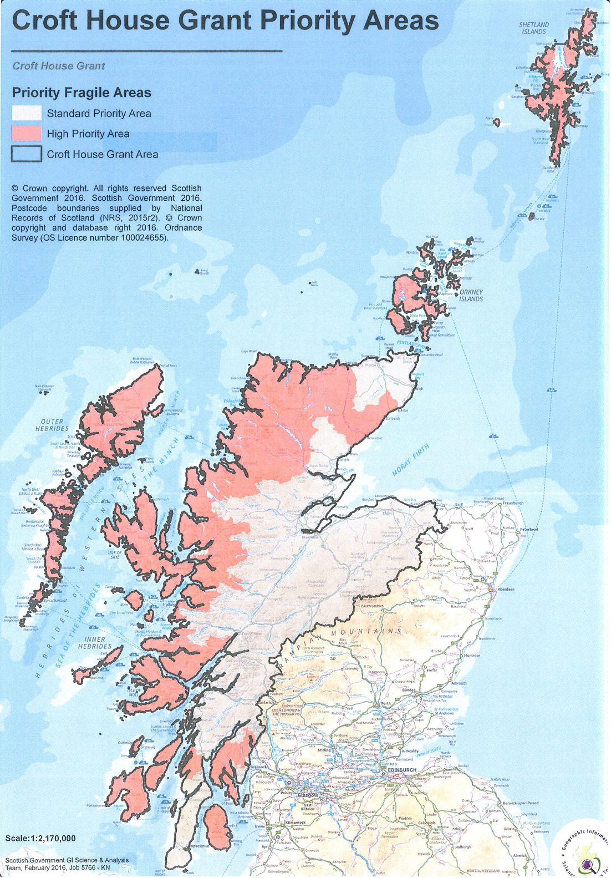Part 2 – Your application

Q1. Applicant status

This question is to establish whether you meet the basic eligibility criteria of the scheme. In order to qualify for CHG you must be one of the following:

Are you: Tick one only

A Crofting Tenant

An Owner Occupier Crofter

A Cottar

A Kyles Crofter

All of the above are defined in the Crofters (Scotland) Act 1993 (as amended).

Q2. Personal details

This question is to obtain basic information about you, the applicant. In every case
it is necessary to check our records for previous applications and for details of assistance given in the past. This is why we wish to know the previous surname used including the maiden name of married female applicants.

Full Name

Any previous surname
(such as a maiden name)

Date of Birth / / Email address

Q2(a) – Other family members

We need to know who lives in your current house.. You should only include people who will be staying with you on a permanent basis.

Please provide details of other family members who live with you on a permanent basis at present.

Full Name | Relationship to the applicant | Age if under 21 years old

Q3. Details of your present accommodation

Address*

Postcode Telephone number

How many rooms do you have for your use at your present accommodation?

How many of these are bedrooms?

*Please enclose proof of address (bank statement, utility bill dated within the last four months or a copy of your full driving licence).

Q3(a). Distance from croft

How far away from the croft do you live at present (give distance by road in miles)?

Do you have the use of any other house, other than your present accommodation?

Yes No

Q3(b). Landlord (if owner occupier go to Q5a)

We need to know the name and address of your landlord as they will be informed if your application is approved.

Full name and address of your landlord or landlord’s agent

Postcode

Name of estate (if applicable)

Q3(c). Previous accommodation

We need to know what your accommodation arrangements have been for the last five years, in particular if you or your spouse/partner has sold a house or given up a rental property.

Please use the table below to provide a complete history of you and your spouse/partners accommodation arrangements for the last five years.

Address | Number of rooms in the property | Number of bedrooms in the property | Type of Occupancy | Dates of occupancy | Reason for Giving up/sale

Q4. About the croft

This question is to establish the basic information about where the house improvements are going to take place. We need the name of the parish in which the croft is located for preparing legal documents if assistance is given. We need the location code and business reference number to properly identify the croft.

You must enter your postcode as this will determine the priority area of your croft.

Croft address (if different from postal address)

Postcode County

Parish

Has housing grant assistance been given on this croft within the last 10 years ? Yes

No

If yes, give date assistance was received / /

Main location code

Business Reference Number

Q5. Assignation/re-let

This question helps us determine if you are a crofter, particularly if there was a recent assignation/re-let

Delete as appropriate

If the croft was assigned/re-let to you, please give the following details:

Date of assignation/re-let / /

Name of person who assigned/re-let the croft to you

If the croft was assigned/re-let to you by a member of your family, what is their relationship to you?

Please enclose copy of letter from the Crofting Commission, which you received, confirming details of the assignation.

Q6. Other houses on croft

Is there another house on the croft? Yes No

If yes, please explain the details of this other house in the box below (including a description of the house, who has ownership of the house and its condition).

Q6(a). House site Decrofting (if owner occupier go to Q7)

If you are a tenant you should indicate below whether you have decrofted and purchased or intend to decroft and purchase the site of the house to be improved. Please note that you may need to consider decrofting your house site for mortgage purposes.

Has the house site been decrofted and purchased? Yes No

If not, is it your intention to decroft the house site
and purchase Yes No

Crofting tenants who have already decrofted and purchased their house site should submit a copy of their title with this application. Crofting tenants who intend to decroft and purchase (if tenant) will need to inform RPID Tiree as soon as possible after the process has concluded.

Q7. Cost/estimated cost for your energy efficiency improvement

Please note that energy efficiency improvements assistance can only be given if the total cost of the project is over £8,000. Please provide the estimated cost of the energy efficiency improvement works below. This should be supported by at least two competitive quotations for the work, and three competitive quotations where one has been provided by a contractor connected to you.

The cost/estimated cost of the energy efficiency improvement is £

If you are receiving grant assistance from another public source for this project then you may not eligible for CHG assistance. You should consult the RPID Tiree office to make sure there are no double funding issues.

Applicants must submit plans showing proposed floor layouts and room sizes with their application for CHG funding. Plans must provide sufficient detail for a floor area calculation by RPID (for details of standards of house plans required, please refer to the CHG Applicants Guidance).

You will also be required to attach a map showing where the house is situated on the croft.

Please provide a description of the energy efficiency measures you propose below (these measures must be included in an associated valid Energy Performance Certificate (EPC) submitted along with this application:

Q8. Income details to justify assistance

To allow us to assess your application correctly we require you to confirm below what your combined net household income* is after deductions such as Income Tax and National Insurance. You must also submit proof of income from all employment and certain other** income.

*Proof of income from employment is P60s for the last three years for you (and your partner, if they will reside in the croft house) for all of your employments. You should include P60’s for all jobs that you have had during these years. Written confirmation of gross salary minus tax and NI contributions from present or previous employers is acceptable. If you or your spouse/partner is declaring foreign income then a letter from the employer confirming their foreign income is acceptable. Also if you (or your partner) have been in your current role for less than one year written confirmation of salary from your employer is acceptable.

**Other income includes pension statements for the last three years (or since you retired if less than three years ago) or HMRC Tax Returns for the last three years if self-employed.

Your combined net household income Tick one only

Combined net household income of £24,000 and under

Combined net household income of £24,001-£29,999
Combined net household income of £30,000-£44,000
Combined net household income of £44,001-£63,000
Combined net household income of over £63,001

In addition to the requirement to submit proof of income, please complete the tables below detailing you and your partners (if they will reside with you) employment for the last three years. Please note that if we do not receive P60/HMRC tax returns etc for all employments or income sources for you and your partner for the period specified, your application will be refused for grant.

Applicants Employment

Company | Job title | Remuneration | Duration of employment

Applicant’s Spouse/Partners Employment

Company | Job title | Remuneration | Duration of employment

Q8(a). Any property on or off the croft that could or has been sold to fund the proposed rebuilding or improvement works

Again, to allow us to assess your application correctly, please would you confirm below, if you or your spouse/partner have any property on or off the croft which could or has been sold to fund the rebuilding or improvement works. You will also need to provide evidence of any outstanding mortgage settlements.

Do you have: Tick one only

No previous property
Property sold or retained but showing asset
value under £50,000
Property sold or retained but showing asset
value of £50,001-£100,000
Property sold or retained but showing asset
value of £100,001-£149,999

Property sold or retained but showing asset
value of over £150,000*

*Please note that if your property asset value is greater than £150,000 you are not eligible for support under CHG

Address of property sold or retained

Amount the property was/is valued at

Amount the property sold for (if applicable)

Outstanding mortgage

Profit/Loss

For current fixed assets the value of asset must be confirmed in writing by a suitably qualified surveyor if the application is successful. For assets sold within the last five years you will need to provide a copy of the title from the record of titles.

Please use this box to provide any other info regarding other property sold or retained by you or your spouse/partner

Q9. Details of land

Please note that you will be required to submit a five year business plan for the croft which you agree with us and you must adhere to (there is a five year plan template at the back of this application form for applicants use). If successful, it will be a condition of your grant award that you maintain the crofting activity achieved in year 5 of your business plan until the end of your (10 year) grant conditions.

Area of croft (in hectares)
Rough grazing (in hectares)
Improved ground (in hectares)
Details of any common grazing shares

Q9(a). Details of any other permanent land held

Code number | Name of croft/holding | Area in hectares

Q9(b). Current and proposed activity on croft and common grazing (CG)

Crops (please specify) |  | Hectares
Stock | Present number |  | Proposed number
Breeding cows on the croft
Breeding ewes on the croft
Other (specify) on the croft
Breeding cows on the CG
Breeding ewes on the CG
Other (specify) on the CG
Q10. Management of croft

Please provide details on who will carry out the day-to-day work on the croft.

Q11. Non-agricultural business activity

We need to know details of non-agricultural activity on the croft if you intend to make this the justification for living on your croft. If the business activity is at the proposal stage and you have a business plan, please submit a copy of the business plan along with your application.

Describe current or proposed non-agricultural business activity on the croft.
(continue on separate sheet if necessary)

What is your role in the business?

How long have you been involved in this
business (years and months)

If it is your own business, how long
has the business been trading/operating?

If already established, where does the business operate from, at present?

Why do you wish to move the business to your croft?

Do you employ others in the business
(please state how many)?

What would happen to the business, if you continued to live at your present address?

Part 3 – Further Guidance

Checklist for applicants

The checklist below is to help you ensure that you have provided all the documentation that is required to allow us to process your application.

Please tick off the documentation which you must send to support your application below. If the relevant documentation is not provided with your application this could lead to a delay in processing your application or it being rejected.

- Applied to your local RPID office for a Main Location Code and Business
Reference Number (if you do not already have one) – All applicants

- Copy of proof of address (a bank statement or utility bill, driving
licence) – All applicants

- Copy of details of assignation/succession from Crofting Commission/landlord
etc – All applicants

- Copies of P60 for all employments, tax return, pension statements (three years)
for both the applicant and their partner (if applicable). Written confirmation showing
gross salary minus tax and NI contributions from present or previous employers is
acceptable. If the applicant is declaring foreign income then a letter from their employer
confirming their foreign income – All applicants

- Agricultural evidence (i.e. five-year plan), including details of stocking and cropping
activity – All applicants indicating agricultural activity on their application. There is a
template at back of this application form for the applicants use.

- Business evidence (i.e. business plans, current business details) – All applicants
indicating non-agricultural business activity on their application.

- Copy of detailed house plans (for details of standards of house plans
required, please refer to the CHG Applicants Guidance) – All applicants

- Map showing location of house contained in application – All applicants

- Copy of any mortgage statements for current fixed assets. For any properties
sold in last five years a copy of a solicitors letter confirming the sale price along with
associated mortgage redemption certificates – All applicants with current property
assets or property assets sold in the last five years.

- Copy of the title deeds for the house – All applicants who have Decrofted and
purchased their house.

- Evidence of crofting activity (livestock records, invoices for livestock, seeds,
contractors etc) – All applicants who have crofting activity at time of application

- At least two competitive quotes for the work (three if one of the quotes is from
a relative) – All applicants

- Copy of a valid Energy Performance Certificate (EPC) highlighting required
Improvement measures included in this application – All EEM applicants

- Copy of proposed works specification and plans where appropriate – EEM applicants
The data you have provided in this form is subject to the provisions of the Freedom of Information (Scotland) Act 2002 (FOISA), the Data Protection Act 2018 and the Environmental Information (Scotland) Regulations 2004 (EIR). We will protect personal data we receive in line with the Data Protection Act 2018.

Part 4 – Declarations and undertakings

I declare:

- I have read and I understand the CHG notes for applicants to the scheme.

- I am applying for a grant to rebuild or improve a croft house

- I certify that the information contained within this form is, to the best of my knowledge, accurate and correct and I hereby authorise RPID to make any enquiries necessary to verify the facts.

- I certify that on completion of the work the assisted house will be occupied by me or a member of my family.

- I confirm that if successful in obtaining an award I will operate the croft as an agricultural/business unit for the duration of the grant period.

- I certify that work has not yet started and will not start before I receive written permission from RPID to do so.

- I understand that if I knowingly give inaccurate information or make an inaccurate statement, fail to comply with any statutory obligations under the Crofters (Scotland) Act 1993 (as amended) or if I default on the grant contract under which CHG assistance is paid, I may be required to repay immediately all the CHG assistance advanced.

- I understand that if any of the conditions of grant set out in regulation 4 of the Croft House Grant (Scotland) Regulations 2016 are breached during the 10 year grant period , I may be required to repay immediately a proportion of the CHG assistance advanced together with interest.

- I have received the privacy notice relating to the processing of personal data in connection with the application process for Croft House Grant (as attached to this application form, Pg 17-19).

- I have informed any other individual whose details I have included in this application that I have done so and I have provided them with a copy of the said privacy notice.

I confirm that I have read and understand the points within the above declaration

If you wish for your spouse/partner to correspond with RPID regarding this application please complete the following statement.

I am content for ___________________________________ (name of individual) to discuss my application with RPID or receive/provide information on my behalf as requested by RPID relating to this application.

Signature of applicant

Name
(BLOCK CAPITALS)

Date / /
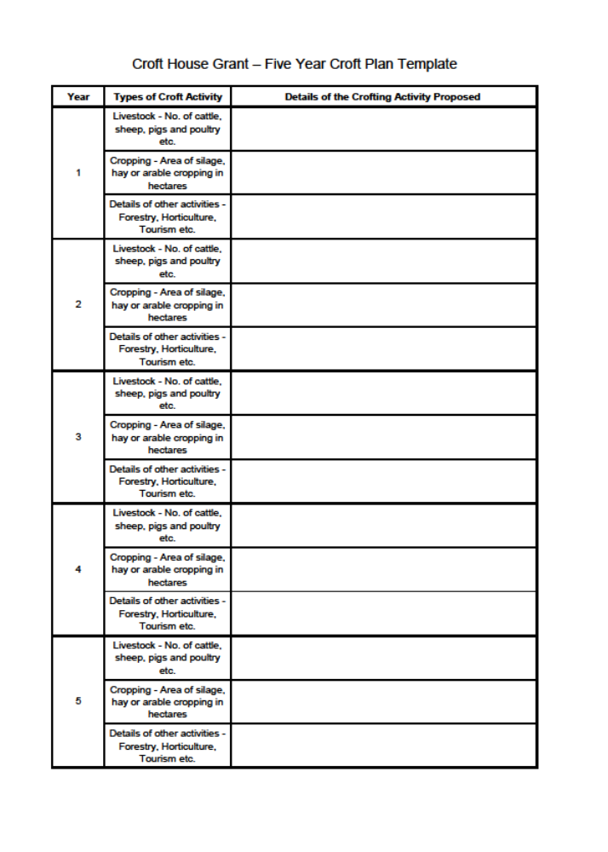 Privacy Notice - Application for a Croft House Grant

Overview
This privacy notice describes how your personal data will be handled by the Rural Payments and Inspections Division (RPID or we) in connection with an application for a Croft House Grant.
RPID is part of the Directorate for Agriculture and Rural Economy in the Scottish Government. This privacy notice is in addition to, not in place of, any general privacy notice published by the Directorate for Agriculture and Rural Economy which can be obtained here: https://www.ruralpayments.org/publicsite/futures/privacy-policy/ or on request from our Data Protection Officer.
For the purposes of the General Data Protection Regulation (Regulation (EU) 2016/679) (GDPR) and the Data Protection Act 2018, the Scottish Government is a data controller in respect of any personal data obtained and processed in accordance with this privacy notice.

How to contact us
If you have any questions about this privacy notice, including any requests to exercise your legal rights, please contact our Data Protection Officer using the details set out below.
By post: Data Protection Officer, Victoria Quay, Commercial Street, Edinburgh, EH6 6QQ
By email: DataProtectionOfficer@gov.scot

To whom does this privacy notice apply?
This privacy notice applies to all individuals who submit an application for a Croft House Grant (Applicants) and to any individuals whose personal data is submitted by an Applicant or whose personal data is otherwise obtained by RPID in connection with such an application for a Croft House Grant (such as family members of an Applicant).

What personal data do we process?
Personal data, or personal information, means any information about an individual from which that person can be identified. It does not include data where the identity has been removed (anonymous data).
We will collect, process and use information as necessary relating to an applicant and any relevant persons related to an applicant (such as family members of an applicant). Such personal data includes identity and contact data, as well as all personal information provided to us in an application form and during the application process for a Croft House Grant.

Other documentation likely to be required
We will also collect personal data in the form of financial information related to an applicant and persons relating to an applicant (such as spouse/partner of the applicant) in the form of income details such as P60 and HMRC tax returns and property asset information such as mortgage redemption statements.

How and why do we process your personal data?
Pursuant to this privacy notice, we process your personal data for the purposes of processing applications for a Croft House Grant, as well as for the purpose of approving Croft House Grants (where appropriate). All such processing is either necessary for compliance with a legal obligation (in particular the Croft House Grant (Scotland) Regulations 2016) or it is necessary for the performance of tasks carried out in the public interest (for example, our task of ensuring that croft house grants are awarded to eligible crofters in Scotland).
We may also process your personal data where we are legally obliged to do so, for example in compliance with our reporting obligations under the Freedom of Information (Scotland) Act 2002.

How do we obtain your personal data?
We will normally obtain personal data relating to an applicant directly from an applicant or an applicant’s spouse, for example through the submission by an applicant of the application form relating to a Croft House Grant or through correspondence with the applicant or their spouse during the application process.
We may obtain personal data relating to other relevant individuals (such as family members of an applicant) from an applicant or an applicant's spouse as part of the application process for a Croft House Grant.
We may receive information about you from a third party during the application process for a Croft House Grant, usually because they are under an obligation to provide the information or we are under an obligation to request the information. Such third party organisations include the Crofting Commission and the Registers of Scotland.
We may also obtain information about you from publicly available sources such as Companies House or other organisations' websites.

Failure to provide personal data
Where we need to collect your personal data in connection with an application for a Croft House Grant and you fail to provide that data when requested, we will be unable to process the application. In this case, we may reject the application.

Who we share personal data with and why
The application process for the Croft House Grant means that your personal data may be made available to other parties involved in the process. We may share your personal data with other organisations, including:
- The croft landlord
- the Crofting Commission
- the Registrar of Scotland
- Home Energy Scotland/Energy Saving Trust

Freedom of Information
RPID (as part of the Scottish Government and a Scottish public authority) is subject to the provisions of the Freedom of Information (Scotland) Act 2002 and the Environmental Information (Scotland) Regulations 2004. We are therefore obliged to consider the release of any information held by us in response to a FOISA or EIR request. In providing any response to a request, we will fully consider our obligations under the Data Protection Act 2018.

International transfers
We do not envisage that any personal data obtained and processed in connection with an application for a Croft House Grant will be or will need to be transferred to a third country (i.e. any country outside of the European Economic Area).

Automated decision making and profiling
We do not use automated decision-making (including profiling) to make any decisions which would produce a legal or similarly significant effect on a data subject.

How long do we keep your data?
We will only retain your personal data for as long as necessary to fulfil the purposes we collected it for, including for the purposes of satisfying any legal, accounting, or reporting requirements.
All applications for Croft House Grant , whether successful or unsuccessful, and any supporting documentation or information will be retained for a minimum period of 7 years after completion of the application process. The Scottish Government's records classification scheme, which includes retention periods, can provide further information. A copy of the records classification scheme can be obtained from the link below or on request from our Data Protection Officer.
https://beta.gov.scot/publications/scottish-government-records-management-plan/

Your rights
You have the right:
- to require to see a copy of the information we hold about you and associated information about how it is being collected and processed;
- to require correction of any inaccurate data;
- to require the erasure of personal data where it is no longer required or for other reasons defined in the GDPR;
- to require restriction of processing of personal data;
- to object to our processing your personal data and to require us to show that the public interest or our legitimate interests override your own interests, rights and freedoms; and
- not to be subject to a decision based solely on automated processing.
In certain circumstances you may have the right to receive personal data that you provided to us in a structured, commonly-used machine-readable format, but please note that this right to data portability does not apply to personal data that we are processing in the performance of a task carried out in the public interest or in the exercise of official authority vested in us.
If you would like a copy of some or all of your personal information or if you wish to exercise any of the rights listed above, please email our Data Protection Officer at DataProtectionOfficer@gov.scot or write to us at the following address:
The Data Protection Officer, Victoria Quay, Commercial Street, Edinburgh, EH6 6QQ

Your rights to complain to the Information Commissioner's Office
Without prejudice to any other administrative or judicial remedy, you have the right to lodge a complaint with a supervisory authority specified by one of the EU Member States.
The UK's designated supervisory authority is The Information Commissioner's Office. Their details are: Helpline: 0303 123 1113 Email: casework@ico.org.uk or scotland@ico.org.uk Website: https://ico.org.uk.
This version of our privacy notice was last updated on 16 January 2019.

